

Spring 2026

Name: Adil Khan
Roll no: 2610-4011
Degree: BS AI

Final Lab

Task no 1:
#include <iostream>
using namespace std;

class Employee {
protected:
double baseSalary;

public:
Employee(double salary) {
baseSalary = salary;
}

virtual double calculatePay() {
return baseSalary;
}
};

class Manager : public Employee {
private:
double bonus;

public:
Manager(double salary, double b) : Employee(salary) {
bonus = b;
}

double calculatePay() override {
return baseSalary + bonus;
}
};

int main() {
Employee emp(50000);
Manager mgr(70000, 15000);

cout << "Employee Pay: " << emp.calculatePay() << endl;
cout << "Manager Pay: " << mgr.calculatePay() << endl;

return 0;
}

Output:
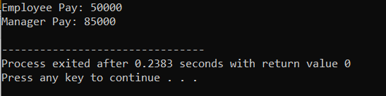

Task no 2:
#include <iostream>
using namespace std;

class Device {
protected:
int powerWatts;

public:
Device(int p) {
powerWatts = p;
}

virtual void showDetails() = 0;
};

class Networked {
protected:
string ipAddress;

public:
Networked(string ip) {
ipAddress = ip;
}
};

class Router : public Device, public Networked {
public:
Router(int p, string ip) : Device(p), Networked(ip) {}

void showDetails() override {
cout << "Power: " << powerWatts << " Watts" << endl;
cout << "IP Address: " << ipAddress << endl;
cout << "----------------------" << endl;
}
};

int main() {
Device* devices[2];

devices[0] = new Router(50, "192.168.1.1");
devices[1] = new Router(75, "10.0.0.1");

for (int i = 0; i < 2; i++) {
devices[i]->showDetails();
}

for (int i = 0; i < 2; i++) {
delete devices[i];
}

return 0;
}

Output:
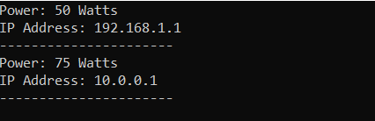

Task no 3:
#include <iostream>
#include <string>
using namespace std;

template <class T>
void swapValues(T &a, T &b)
{
T temp;

temp = a;
a = b;
b = temp;
}

template <class T>
class Storage
{
private:
T data;

public:
Storage(T value)
{
data = value;
}

void setData(T val)
{
data = val;
}

T getData()
{
return data;
}
};

int main()
{
int x = 10, y = 20;

cout << "Before Swap: ";
cout << "x = " << x << " y = " << y << endl;

swapValues(x, y);

cout << "After Swap: ";
cout << "x = " << x << " y = " << y << endl;

Storage<int> intObj(100);

Storage<string> strObj("Adil");

cout << "Integer Data: " << intObj.getData() << endl;
cout << "String Data: " << strObj.getData() << endl;

return 0;
}

Ouput:
